1. Let’s first build an image from Dockerfile.  
   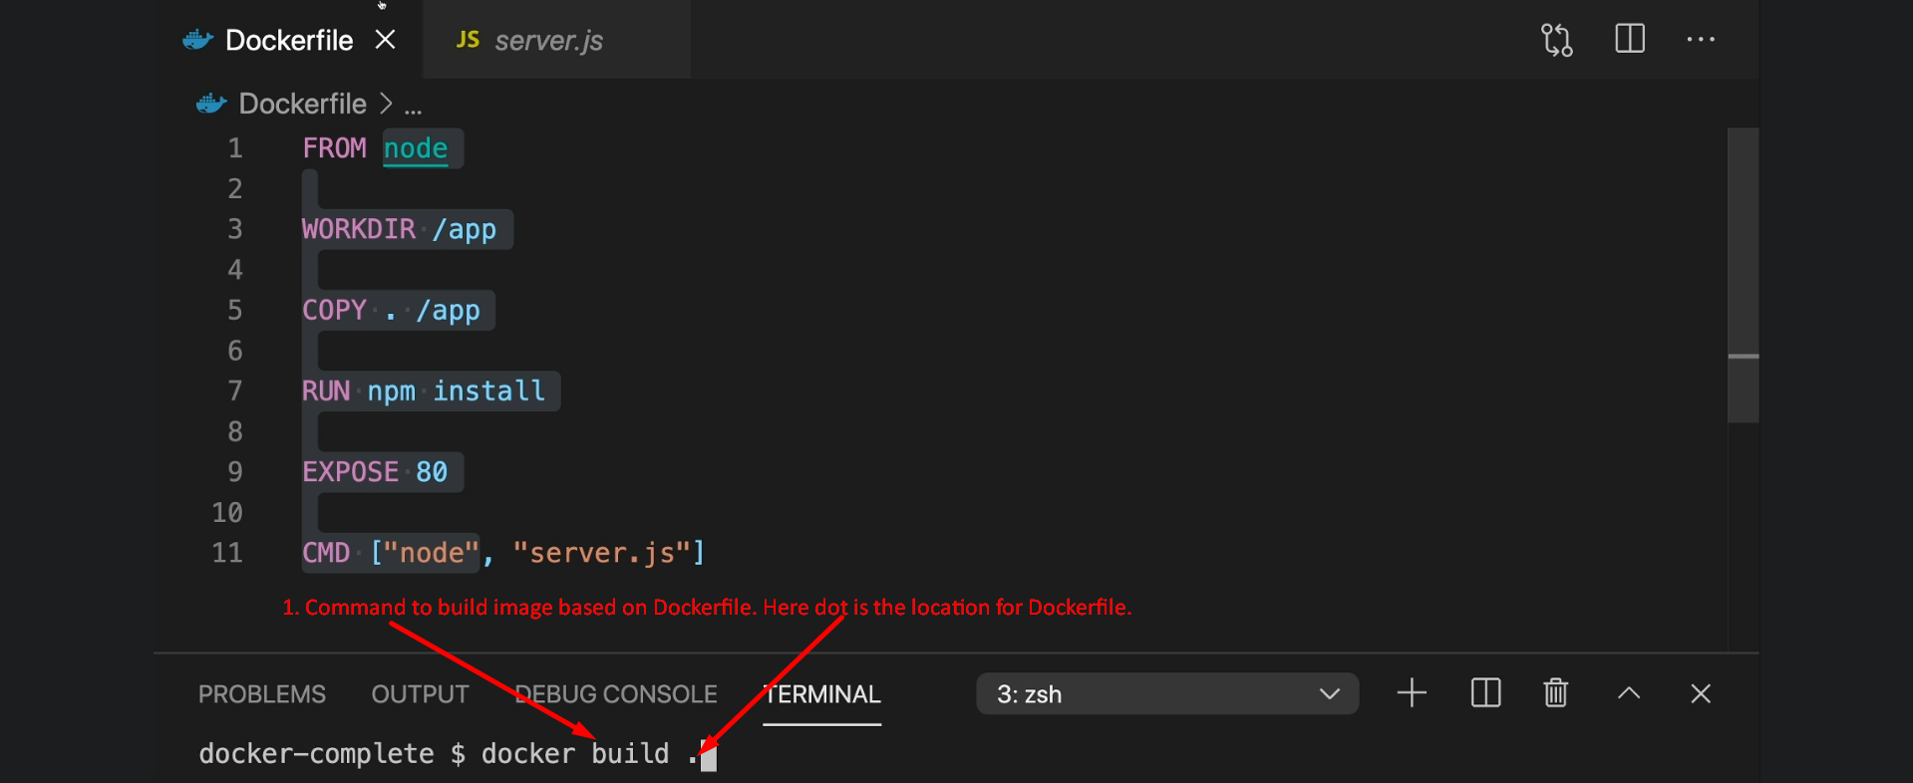  
   **EXPOSE**: This is just for documentation purpose to inform the users about the port on which the running process will be listening.   
   If we don’t mention the EXPOSE 80, still the container will work perfectly as before.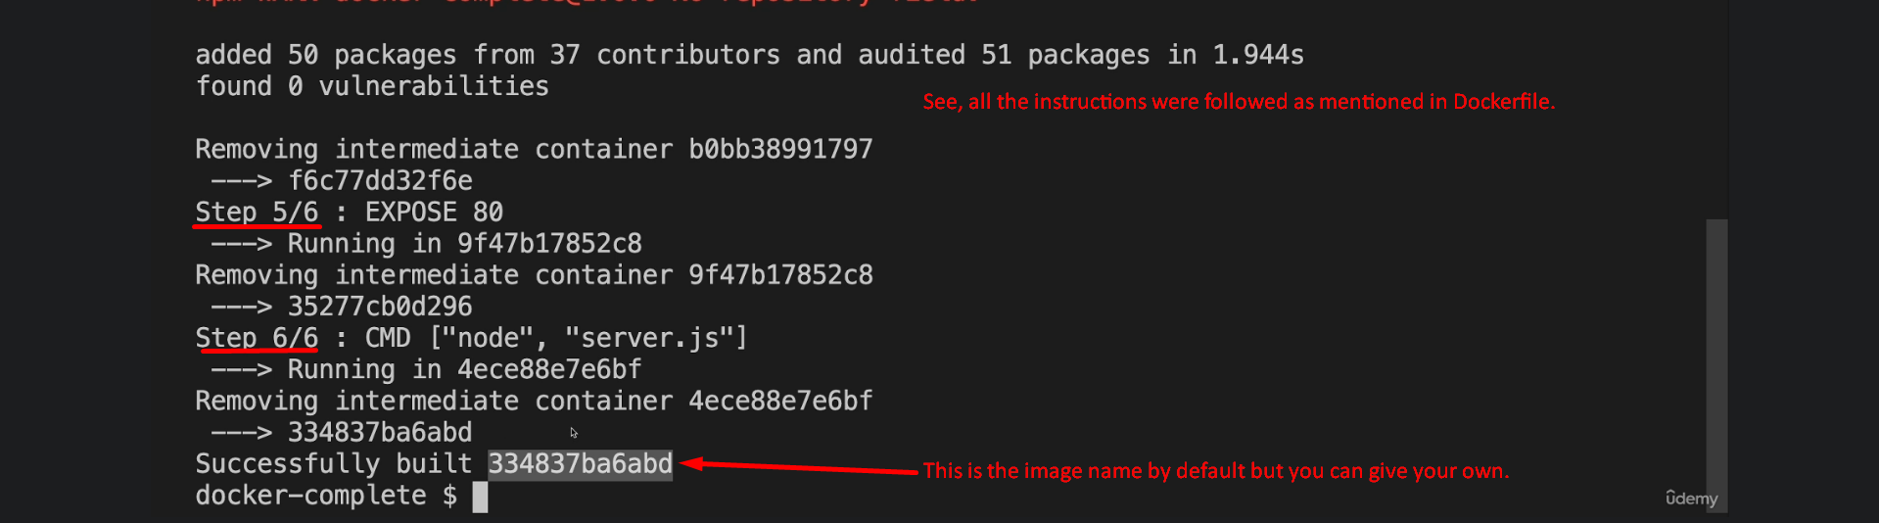
2. 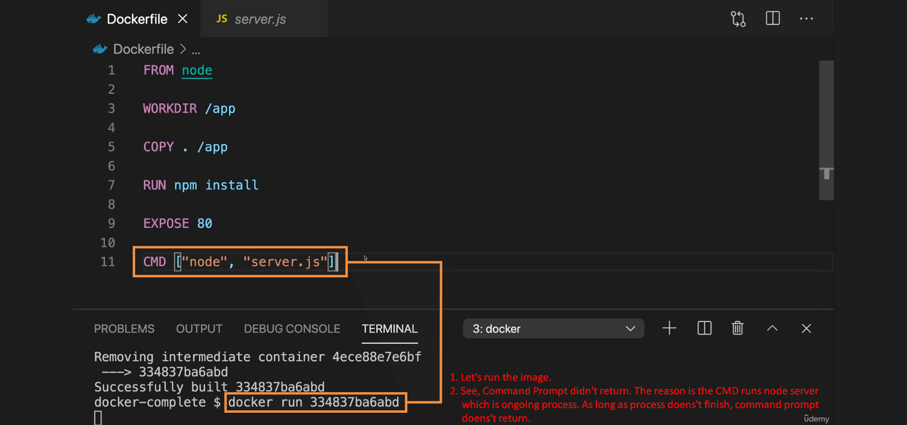
3. 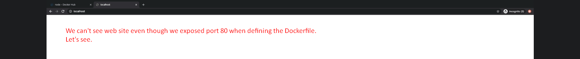
4. 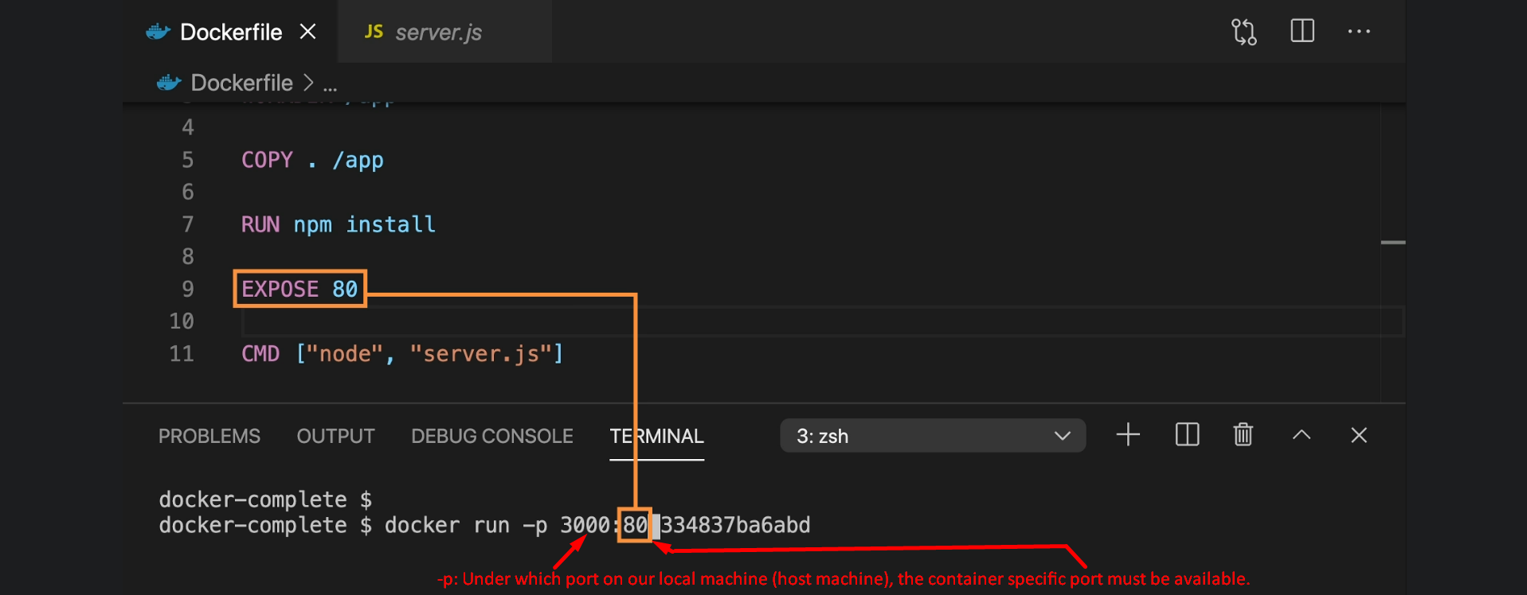
5. 